## Life ray Android example

Hi I am doing Android example using life ray. Here I did sample application in android that is I am peculating the life ray countries table data in Android by using web services.

**The following are the steps to the Android Application.**

**Prerequisites**

We should have minimum development knowledge in **Android application development.**

**Step: 1**

The following tutorial will give good understanding about **Android Application Development**

|  |
| --- |
| <http://www.vogella.com/articles/Android/article.html> |

**Step: 2**

Get the Android Development Tool from Following URL.

|  |
| --- |
| <http://developer.android.com/sdk/index.html> |

**Note: This downloaded rar file having eclipse and Android SDK and Its tools like Android Emulator.**

**Step: 3**

Extract this rar file in your local system. You can find folders name like **adt-bundle-windows-x86** (for windows). If we open the adt-bundle-windows-x86 you can find two folder eclipse and sdk.

The following screen depicts what is available in rar file.

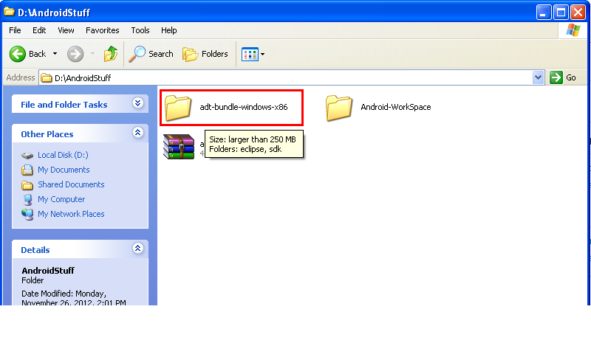

You can find two folders

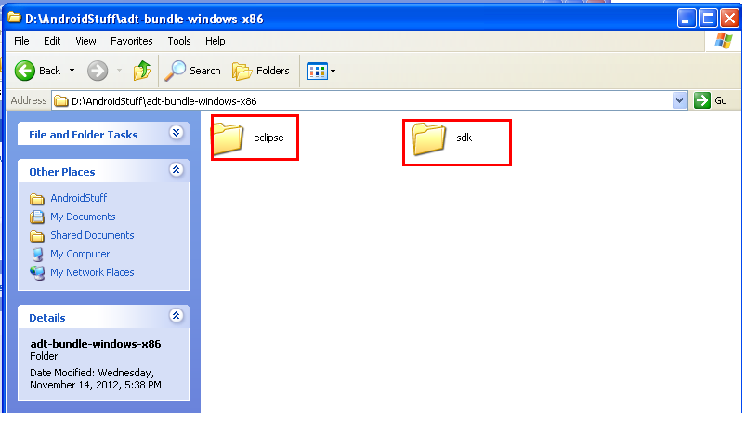

**Step: 4**

Go to eclipse folder and launch eclipse by clicking on eclipse.exe icon.

Now eclipse will be launched and it will ask you work space and select your local work space.

In the below screen you can see the Android icons in eclipse.

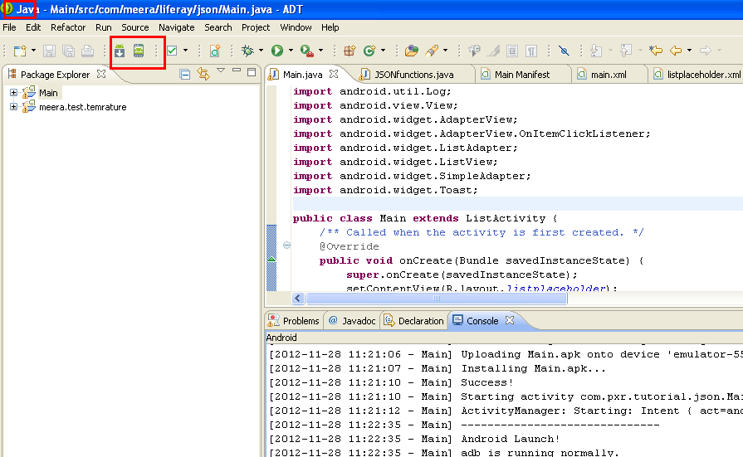

**Step: 6**

Go through following link this tutorial explain how to run basic example in Android.

<http://www.vogella.com/articles/Android/article.html>

Now we have experience with Android Application Development.

# Liferay Android Application

This Life ray Android Application populating Liferay country table countries in Android Mobile.

The concept behind this application is by using **life ray JSON web services** I am populating data in android in grid view by using Android components.

Here we have good experience with calling life ray web services in liferay. The following links are give you good knowledge about how to create **liferay json web services** and how to **consume json web services.**

<http://www.liferaysavvy.com/2012/11/java-client-to-consuming-liferay-json.html>

<http://www.liferaysavvy.com/2012/11/exposing-liferay-custom-json-web_26.html>

Once you read the tutorial then you will get good experience on calling life ray json web service from other client.

**Now you can get Android Liferay Example from following location.**

Once download Android Application .Place application into your android work space and Import this project into your eclipse as Android Existing Application.

**Note: While import you may get some errors so that from the downloaded app you can delete *.project*, *.classpath* and *proguard.cfg* files from your downloaded example before import.**

Once download Android Application .Place application into your android the following are the screens which depicts how to import Existed Android Project into eclipse.

**Screen-1**

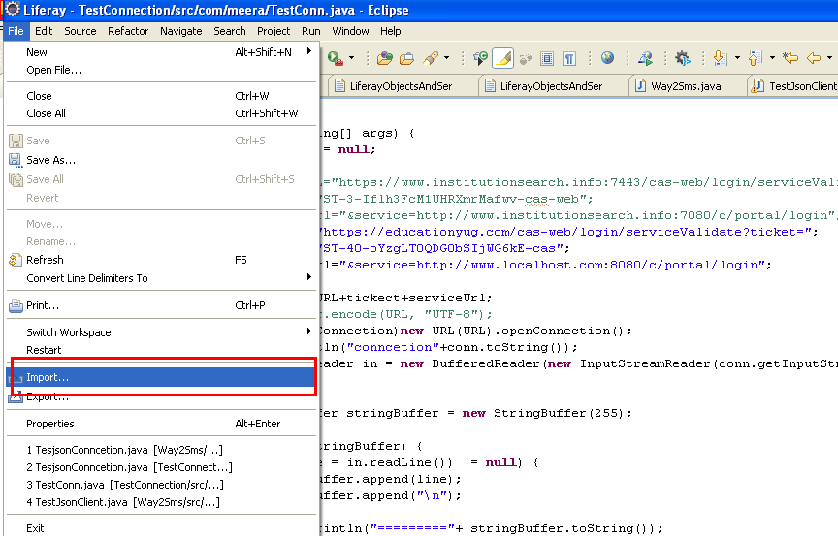

**Screen 2**

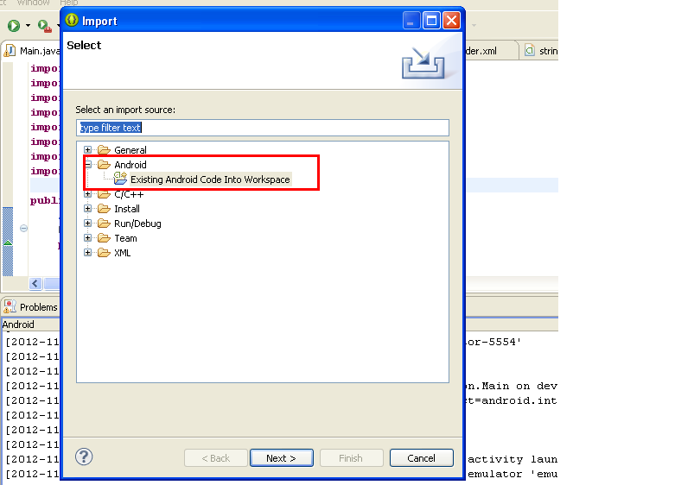

**Screen 3**

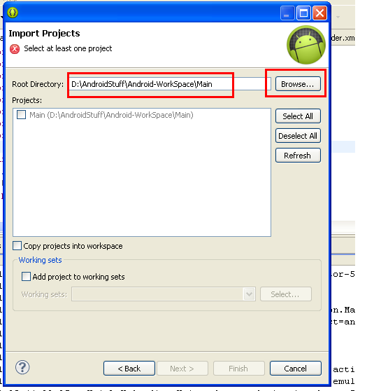

**Run Android Application from eclipse.**

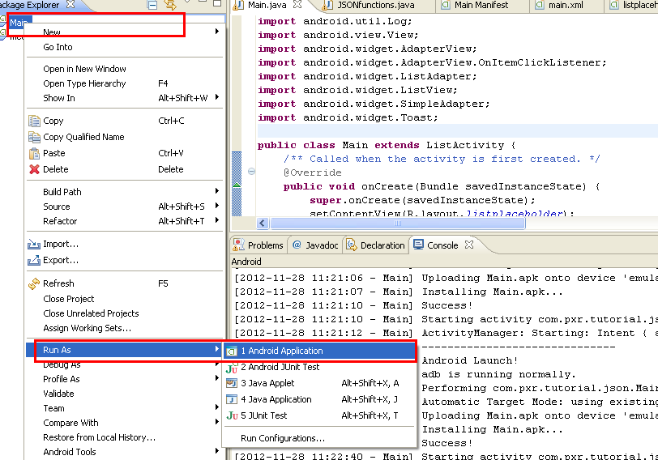

**Once run the project you can observe the following information in console like this.**

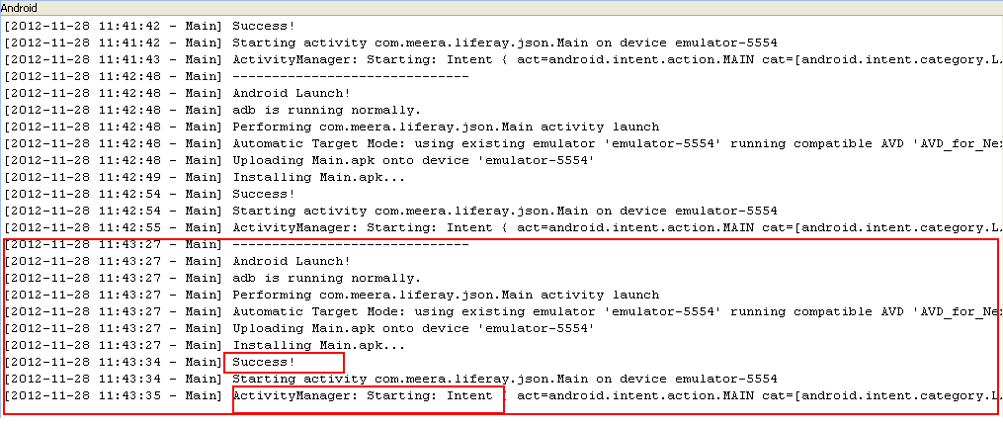

Once application successfully installed then you can find Android emulator there you can see the emulator screen with countries data.

**Important Points:**

In the example to get JSON I am using apache **http client** mechanism.

In that I used URL to connect client and get the data from liferay. In **main.java** class you can find following line.

|  |
| --- |
| **JSONArray countriesJsonArray=JSONfunctions.getJSONfromURL("http://www.yourdomainname.com/tunnel-web/json/?serviceClassName=com.liferay.portal.service.CountryServiceUtil&serviceMethodName=getCountries&serviceParameters=[]");** |

**Note:**

**When use localhost to app that is not working. So your application in network host with domain name (I am not sure but for me it’s not working for localhost ).**

When I used liferay portal which Is in network with [www.xxxx.com](http://www.xxxx.com) then the data is getting in mobile.

